**FIT INDIA MOVEMENT 2024**

Chandigarh College of Engineering and Technology (Degree Wing), Sector-26, organized events to celebrate FIT India Movement on 07 and 08 November 2024 under the guidance of our honourable Principal - Dr. M.S. Gujral, Professor I/C Student Welfare Dr. Sunil K. Singh, President Student Council Dr. Gulshan Goyal and NSS Program Officer- Dr. Sarabjeet Singh

Dr Amit Chhabra and Dr. Sunita coordinated the event

**GROUP PHOTO :**

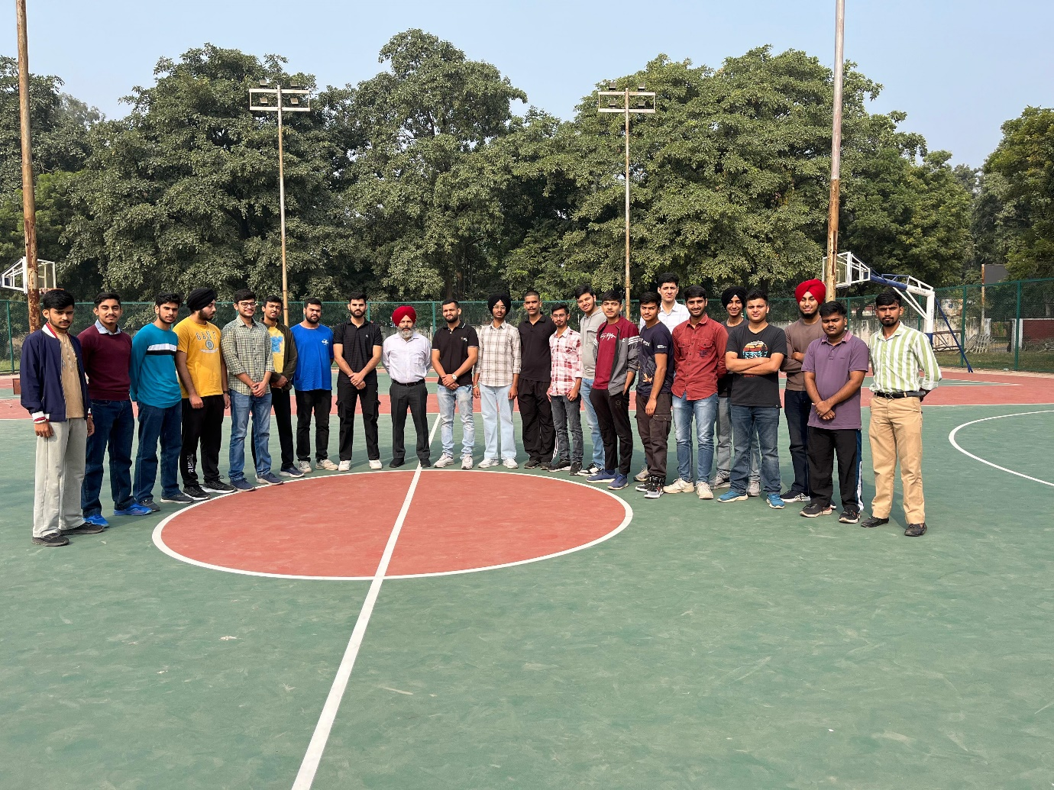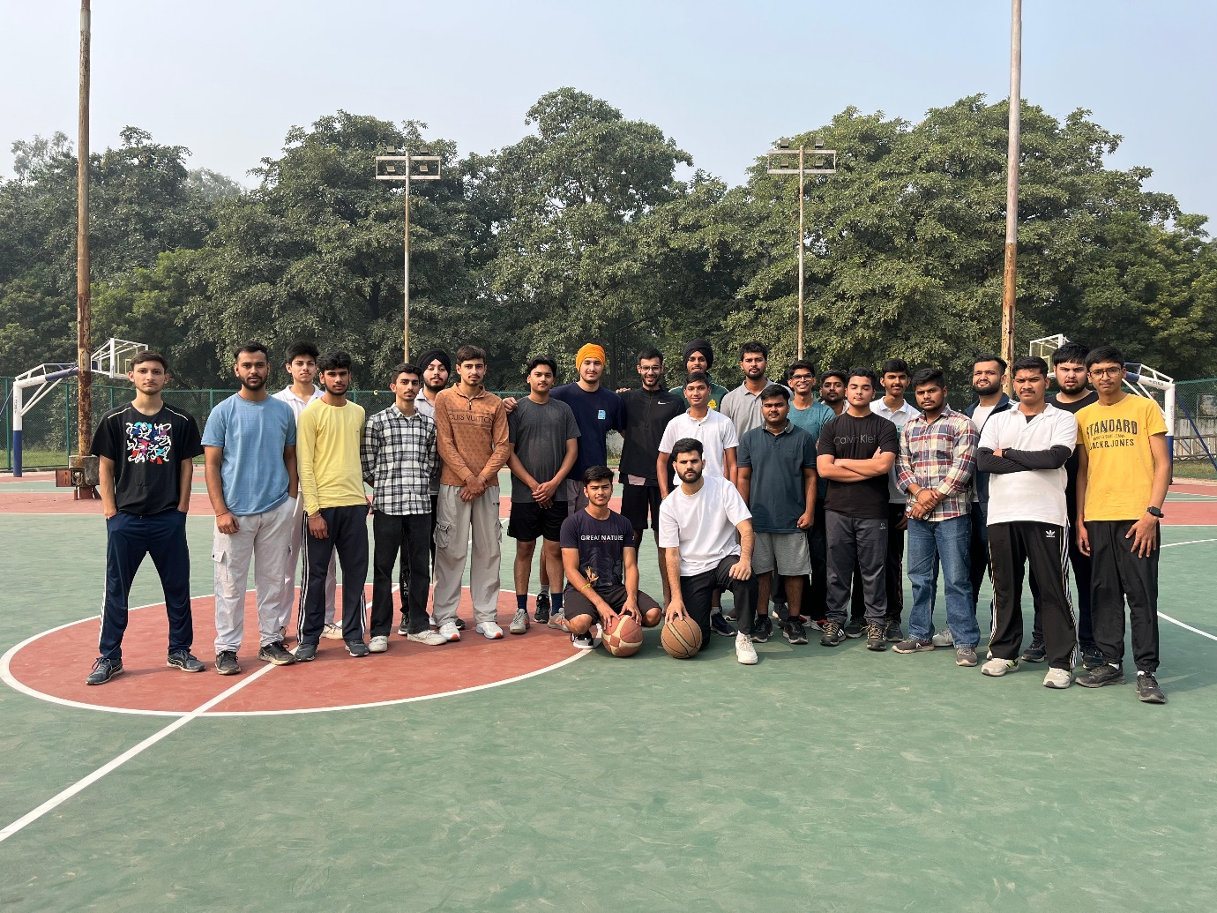

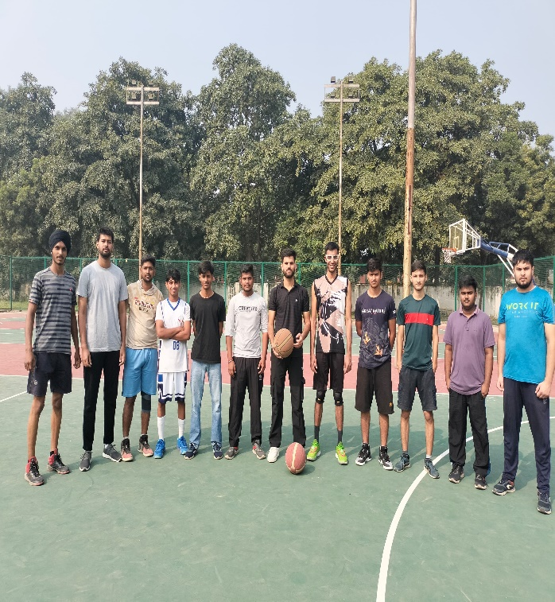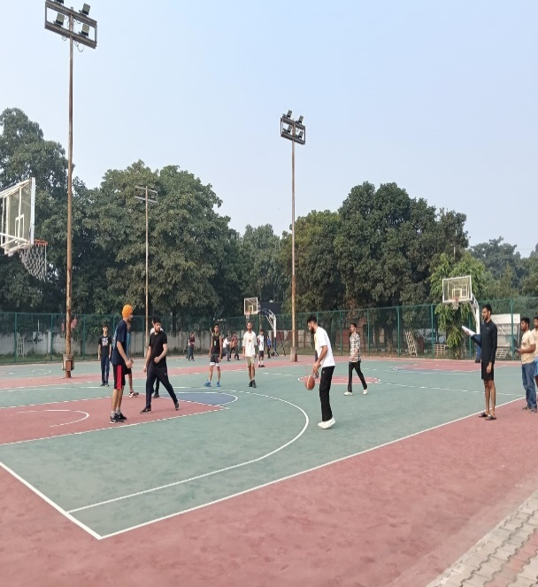

**STUDENT ORGANIZERS :**

1. **SAHIL KONDAL , CSE 3rd YEAR , CO22359**
2. **ANISH SHARMA , CSE 3rd YEAR , CO22308**
3. **MOHD ASHAD , CSE 3rd YEAR , CO22344**

**PARTICIPATED TEAMS :**

**TEAM A**

|  |  |  |  |
| --- | --- | --- | --- |
| **NAME** | **ROLL NO** | **BRANCH** | **YEAR** |
| SHUBHAM | CO23363 | CSE | 2nd |
| ADITYA YADAV | CO21202 | CIVIL | 4th |
| DIVYANSH | CO24216 | CIVIL | 1st |
| ASHUTOSH | CO24208 | CIVIL | 1st |
| CHANDRAMANI SINGH | CO24212 | CIVIL | 1st |

**TEAM B**

|  |  |  |  |
| --- | --- | --- | --- |
| **NAME** | **ROLL NO** | **BRANCH** | **YEAR** |
| SHREYAS CHANDRA | CO24559 | ECE | 1st |
| NAMAN GUPTA | CO24339 | CSE | 1st |
| LAKSHYA RAJPAL | CO24334 | CSE | 1st |
| PRINCE | CO24236 | CIVIL | 1st |
| ISHWINDER SINGH BHATTI | CO22522 | ECE | 3rd |

**TEAM C**

|  |  |  |  |
| --- | --- | --- | --- |
| **NAME** | **ROLL NO** | **BRANCH** | **YEAR** |
| SAHIL KONDAL | CO22359 | CSE | 3rd |
| MOHD ASHAD | CO22344 | CSE | 3rd |
| ANISH SHARMA | CO22308 | CSE | 3rd |
| ROHIN KONDAL | CO24133 | MECH | 1st |
| ARMAAN | CO24104 | MECH | 1st |

**TEAM D**

|  |  |  |  |
| --- | --- | --- | --- |
| **NAME** | **ROLL NO** | **BRANCH** | **YEAR** |
| YUGAM | CO215107 | ECE | 4th |
| BATTH | CO215065 | ECE | 4th |
| PRAESH | CO21553 | ECE | 4th |
| ISHTVEER SINGH | CO21325 | CSE | 4th |
| KUSHAL | CO21335 | CSE | 4th |

**TEAM E**

|  |  |  |  |
| --- | --- | --- | --- |
| **NAME** | **ROLL NO** | **BRANCH** | **YEAR** |
| DEEPINDER SINGH | CO21380 | CSE | 4th |
| TUSHAR BANSAL | CO22373 | CSE | 3rd |
| SUNIL DUTT | CO22368 | CSE | 3rd |
| TARAYAN AGGARWAL | CO21361 | CSE | 4th |
| VPENDER KUMAR | CO24564 | ECE | 1st |

**WINNERS :**

**1ST POSITION:**

**TEAM A:**

|  |  |  |  |
| --- | --- | --- | --- |
| **NAME** | **ROLL NO** | **BRANCH** | **YEAR** |
| SHUBHAM | CO23363 | CSE | 2nd |
| ADITYA YADAV | CO21202 | CIVIL | 4th |
| DIVYANSH | CO24216 | CIVIL | 1st |
| ASHUTOSH | CO24208 | CIVIL | 1st |
| CHANDRAMANI SINGH | CO24212 | CIVIL | 1st |

**2nd POSITON :**

**TEAM C**

|  |  |  |  |
| --- | --- | --- | --- |
| **NAME** | **ROLL NO** | **BRANCH** | **YEAR** |
| SAHIL KONDAL | CO22359 | CSE | 3rd |
| MOHD ASHAD | CO22344 | CSE | 3rd |
| ANISH SHARMA | CO22308 | CSE | 3rd |
| ROHIN KONDAL | CO24133 | MECH | 1st |
| ARMAAN | CO24104 | MECH | 1st |

**3rd POSITION:**

**TEAM D**

|  |  |  |  |
| --- | --- | --- | --- |
| **NAME** | **ROLL NO** | **BRANCH** | **YEAR** |
| YUGAM | CO215107 | ECE | 4th |
| BATTH | CO215065 | ECE | 4th |
| PRAESH | CO21553 | ECE | 4th |
| ISHTVEER SINGH | CO21325 | CSE | 4th |
| KUSHAL | CO21335 | CSE | 4th |